Basic program

Name: suhel

Reg no :192425210

1)Write a c program to perform matrix multiplication

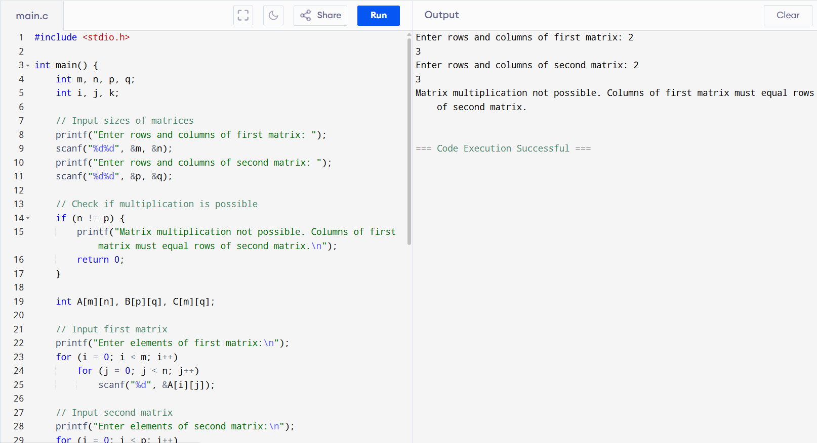

2) Write a c program to find even or odd numbers from a given set of number

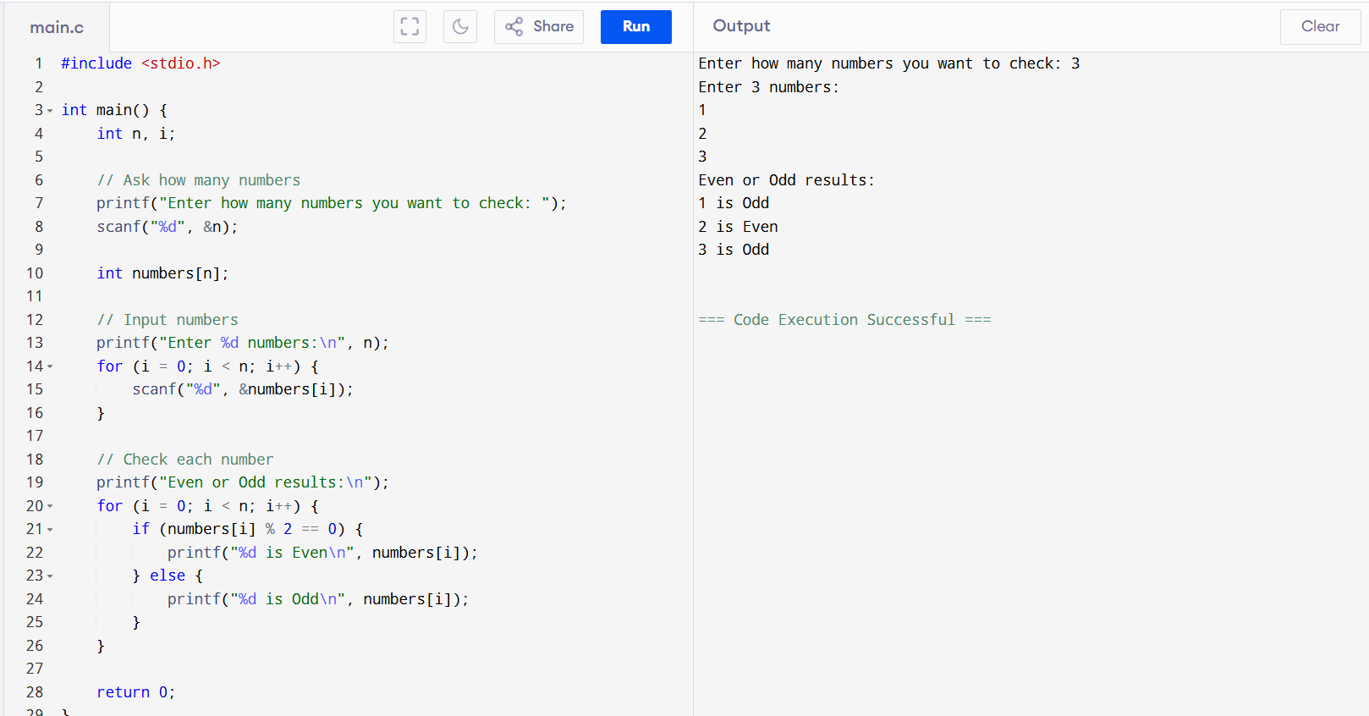

3)write a c program to find factorial of a given number without using recursion.

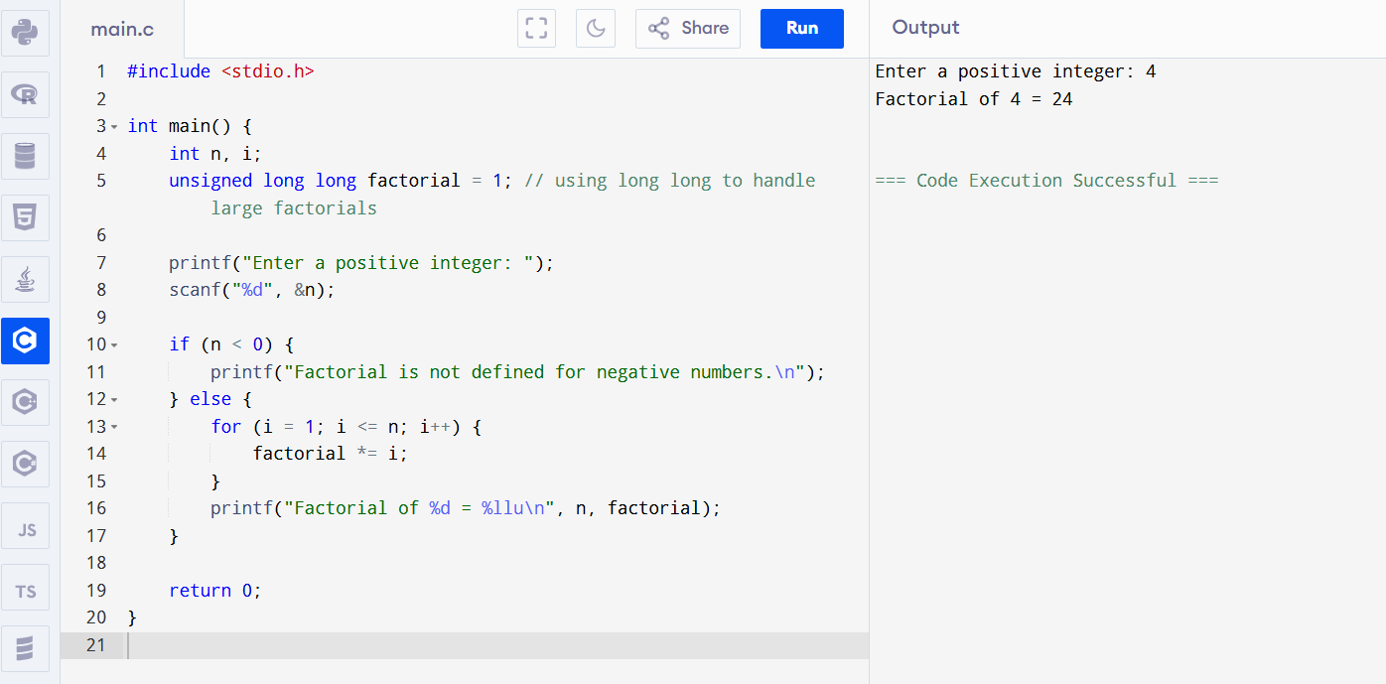

4)write a c program to find fabonacci series without using recurstion

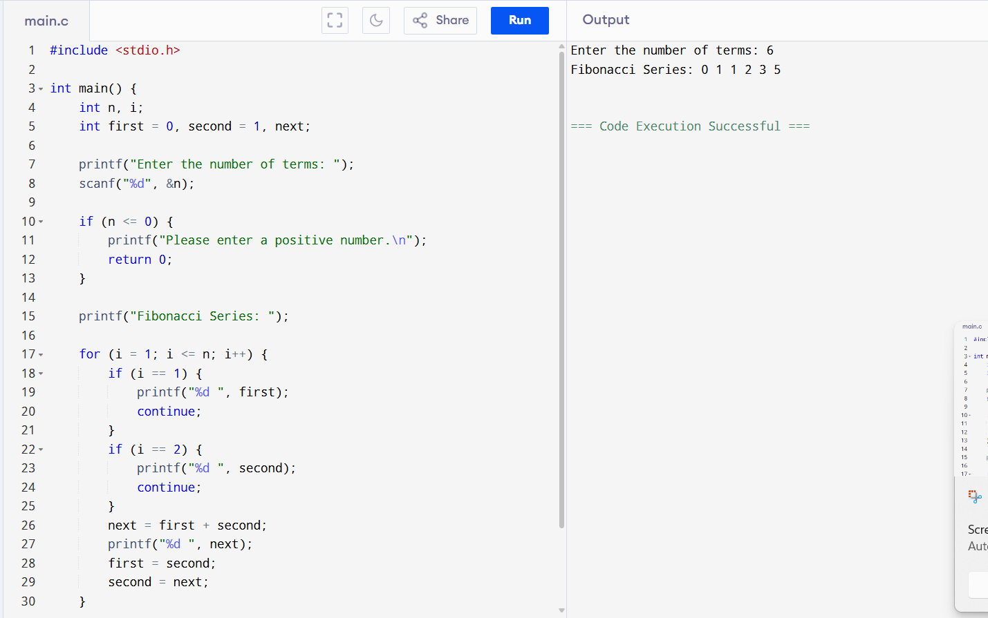

5)write a C program find factorial of a given number using recursion.

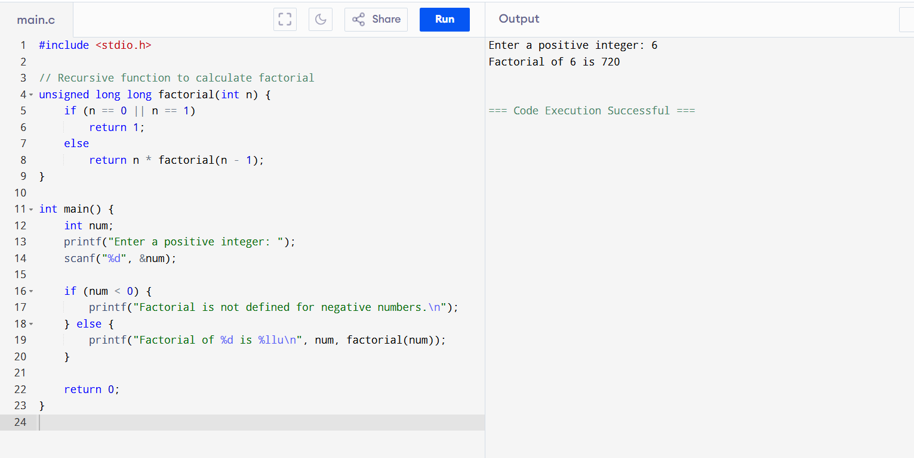

6)Write a C program to find Fibonacci series using Recursion

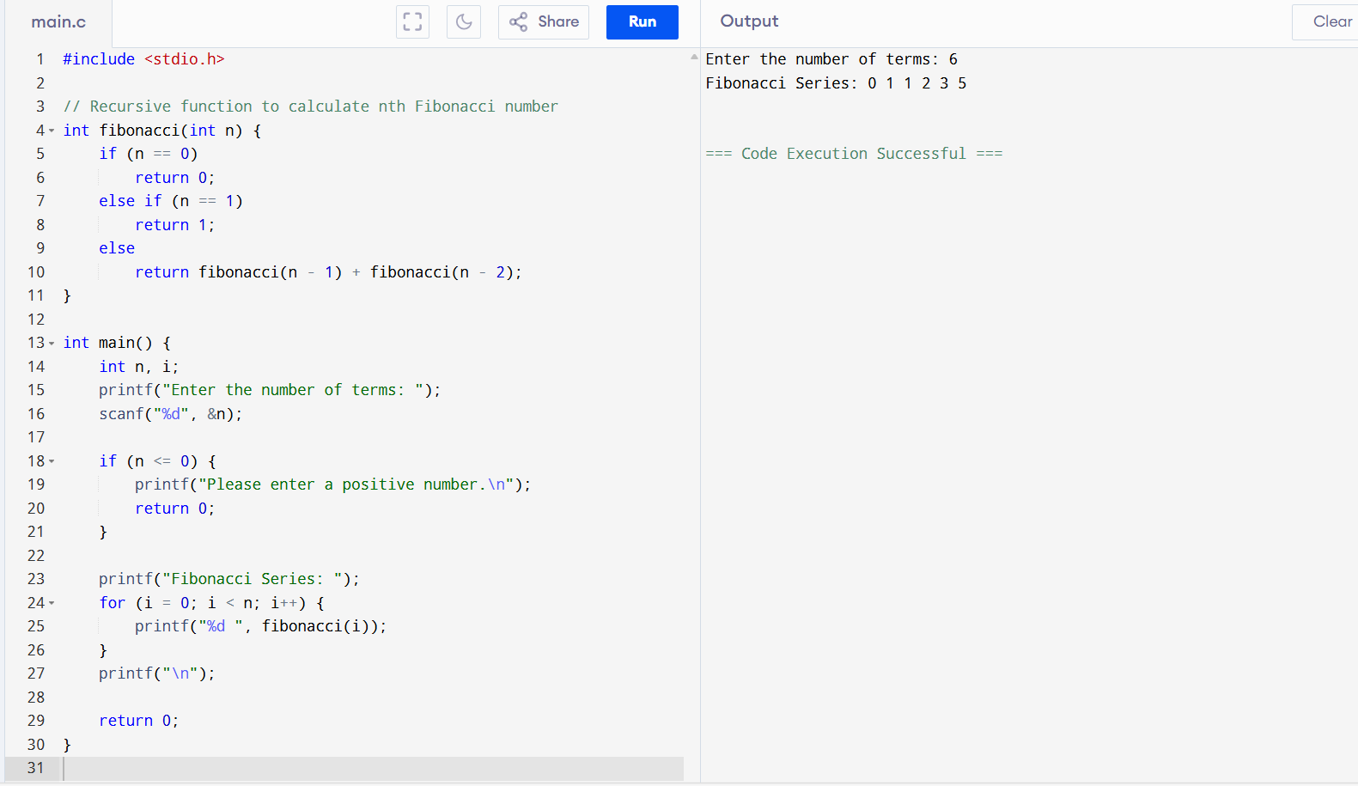

7)Write a C program to implement Array operations such as Insert, Delete and Display

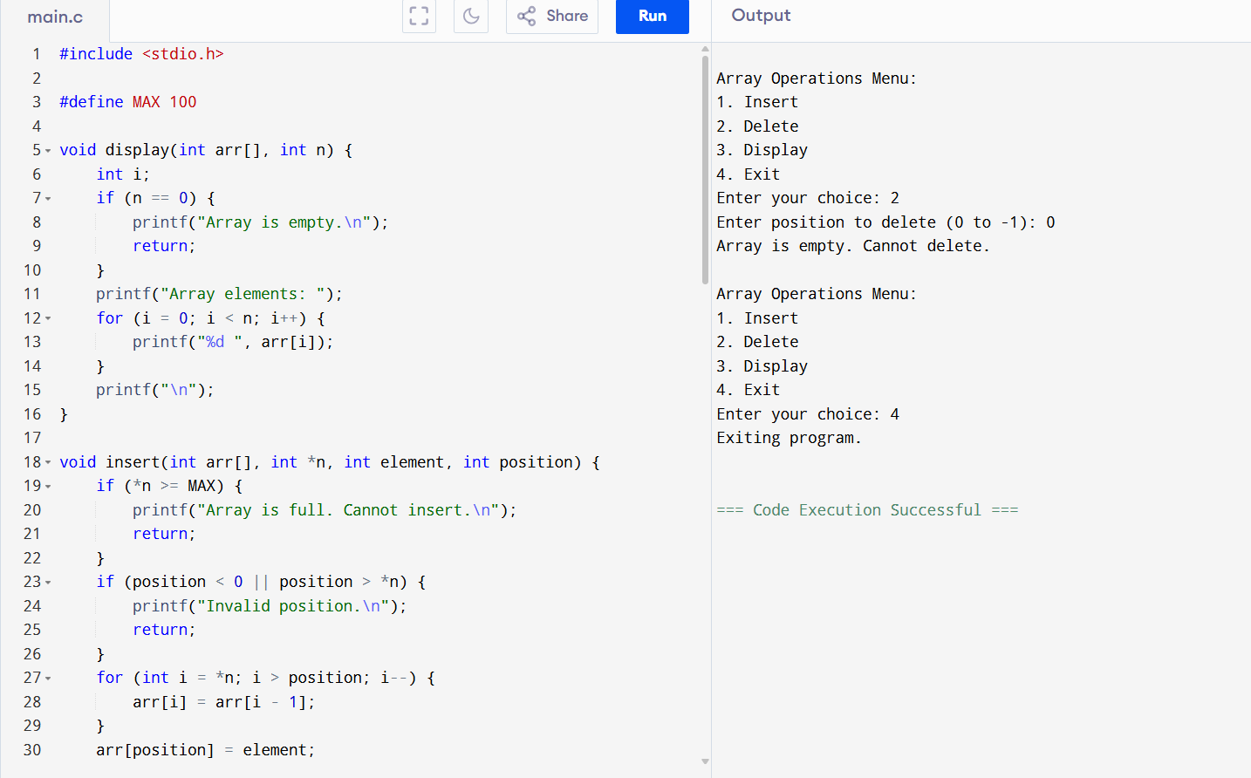

8)Write a C program to search a number using Linear Search method

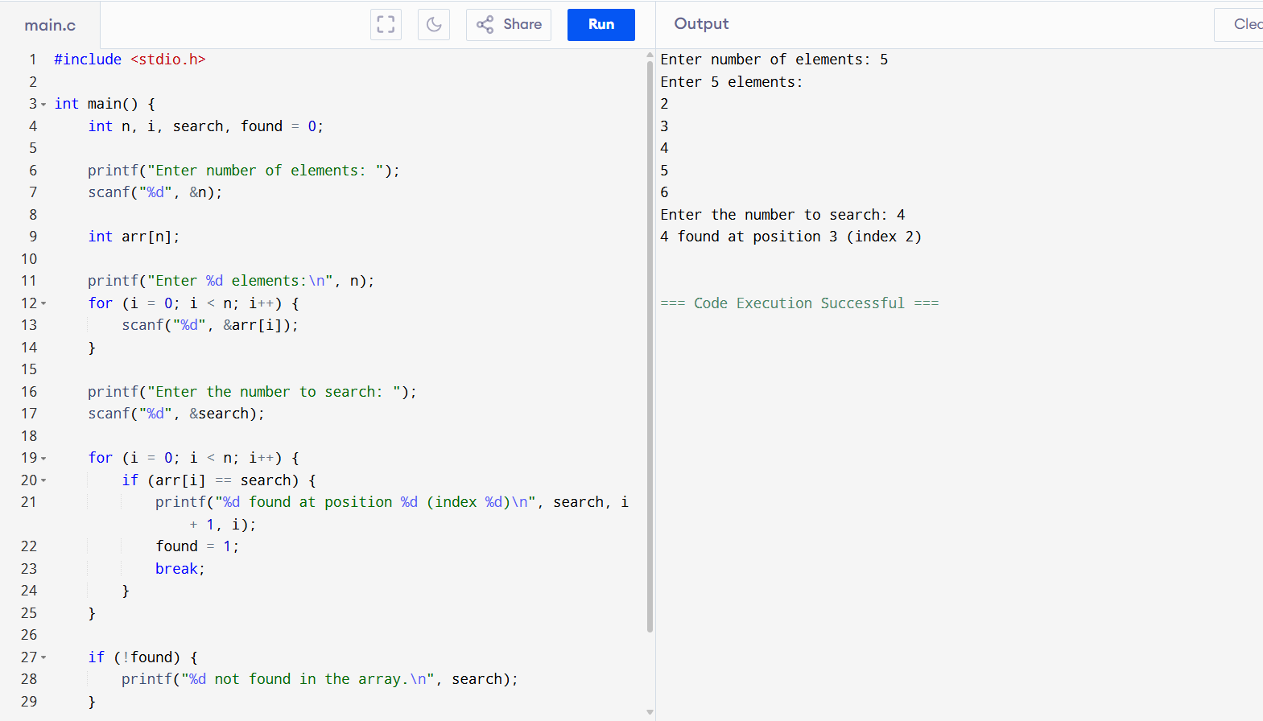

9)Write a C program to search a number using Binary Search method

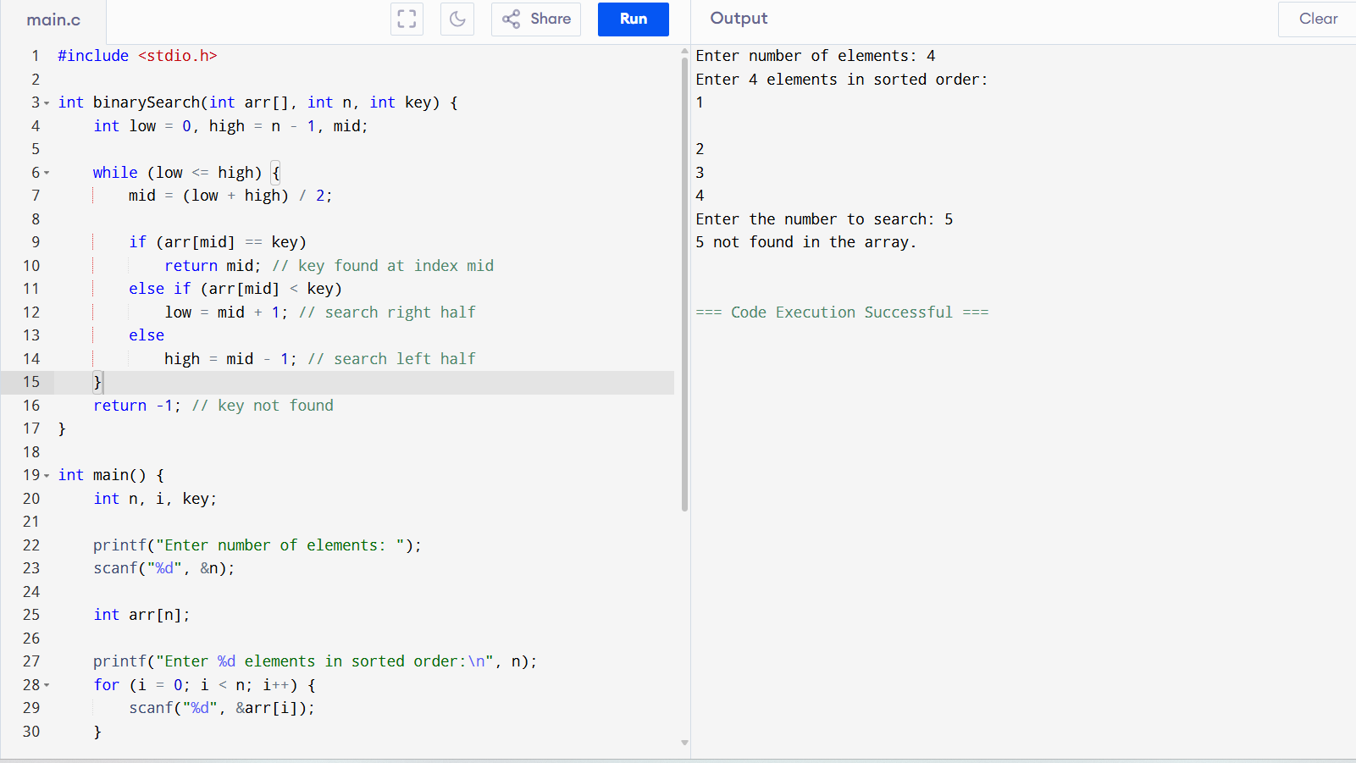

10)Write a C program to implement Linked list operations

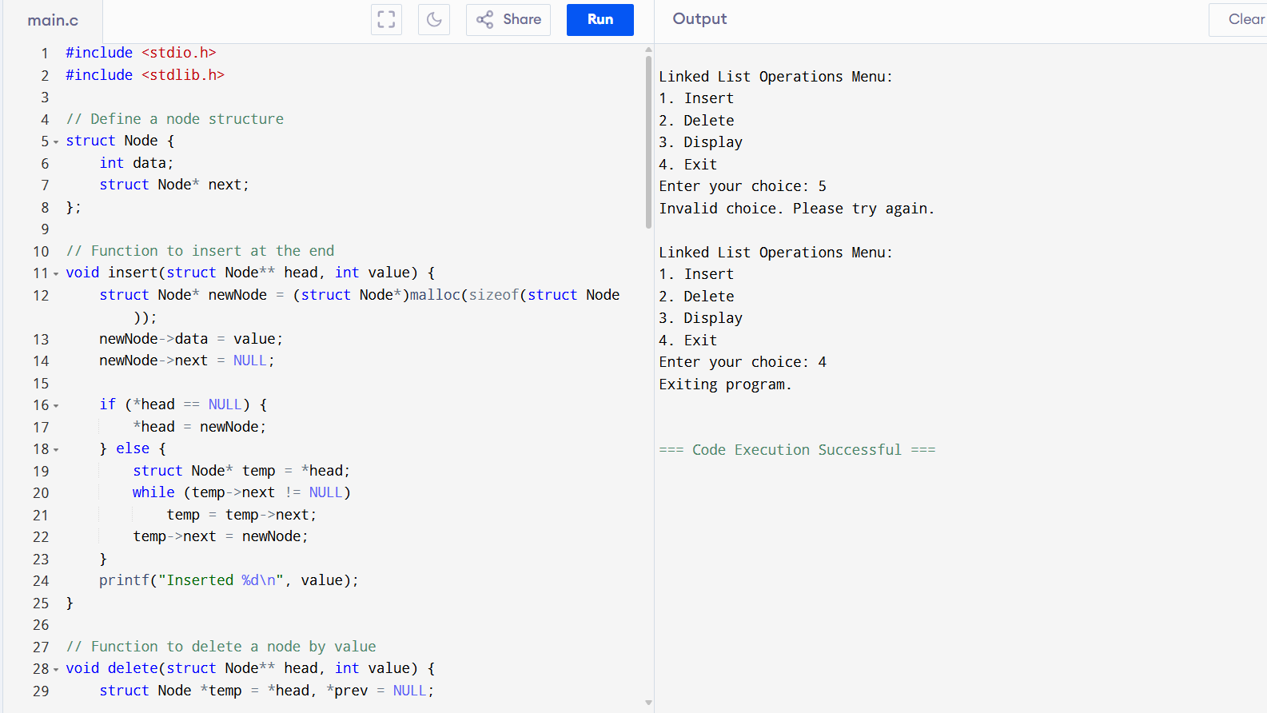

11)Write a C program to implement Stack operations such as PUSH, POP and PEEK

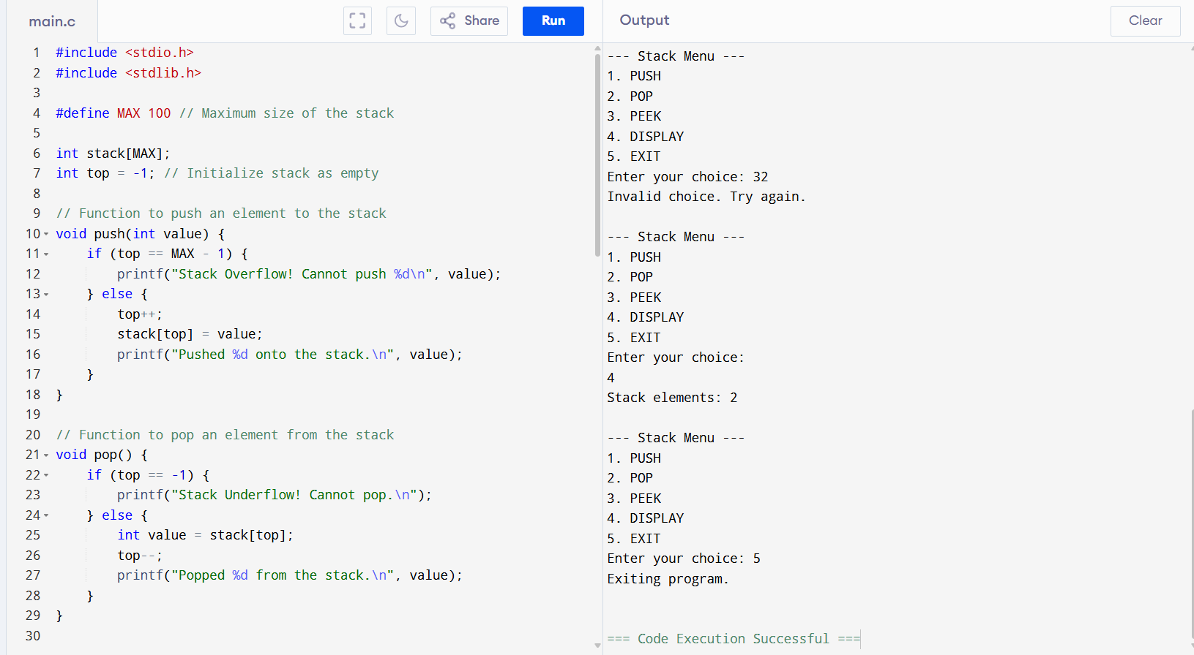

12) Write a C program to implement the application of Stack (Notations)

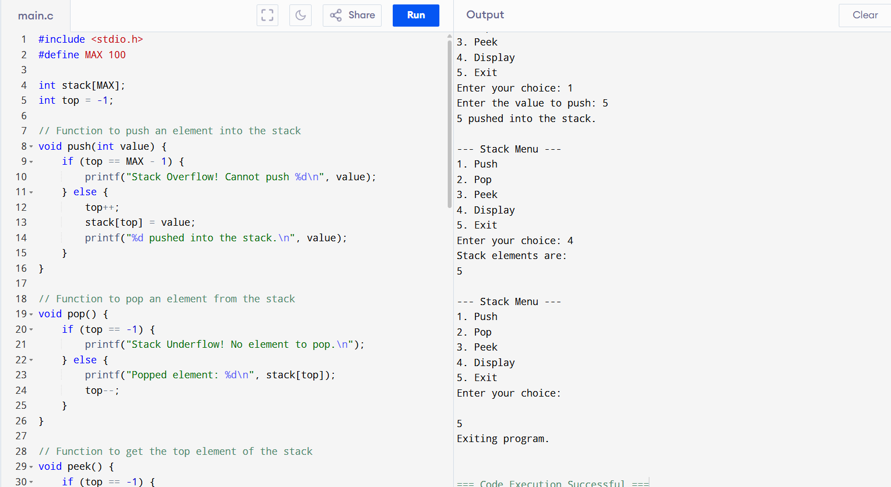

13)Write a C program to implement Queue operations such as ENQUEUE,DEQUEUE and Display

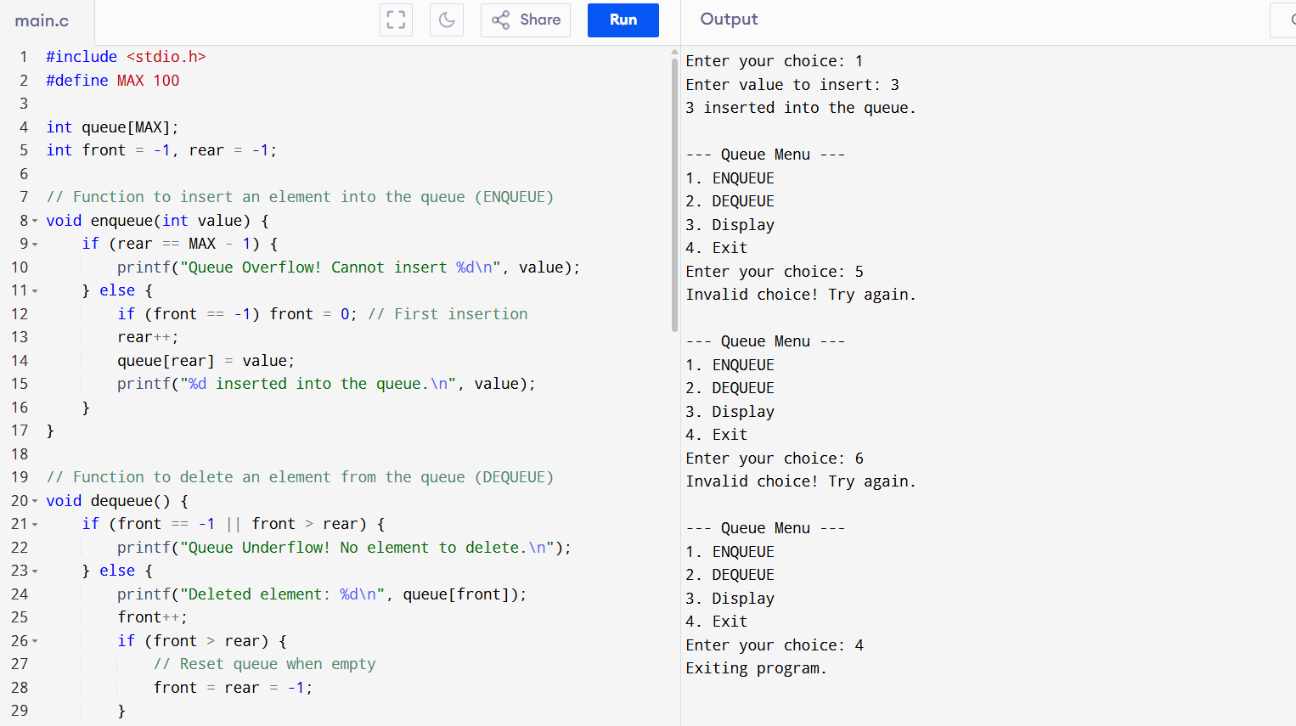

14)Write a C program to implement the Tree Traversals (Inorder, Preorder, Postorder)

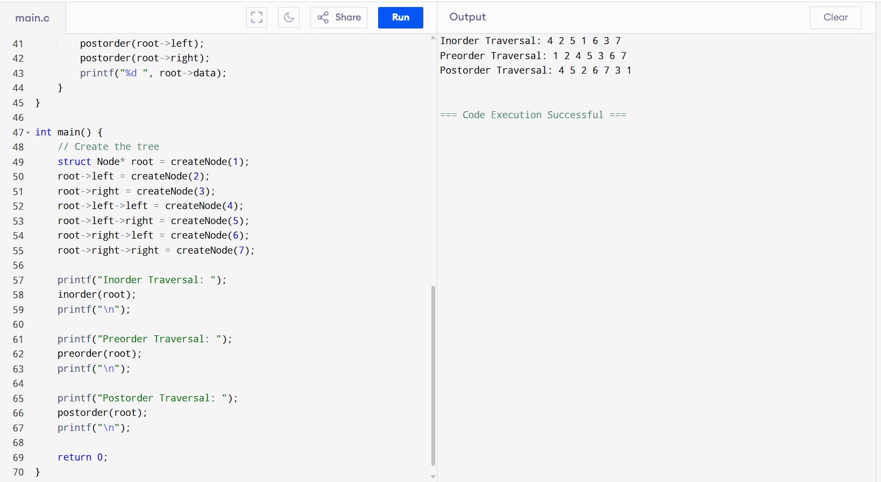

15)Write a C program to implement hashing using Linear Probing method

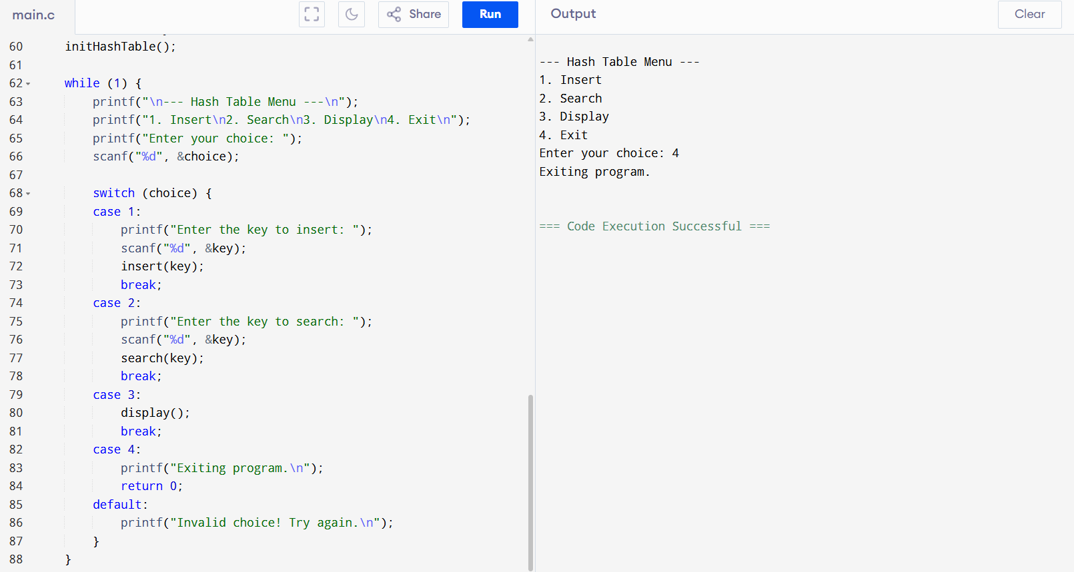

16)Write a C program to arrange a series of numbers using Insertion Sort

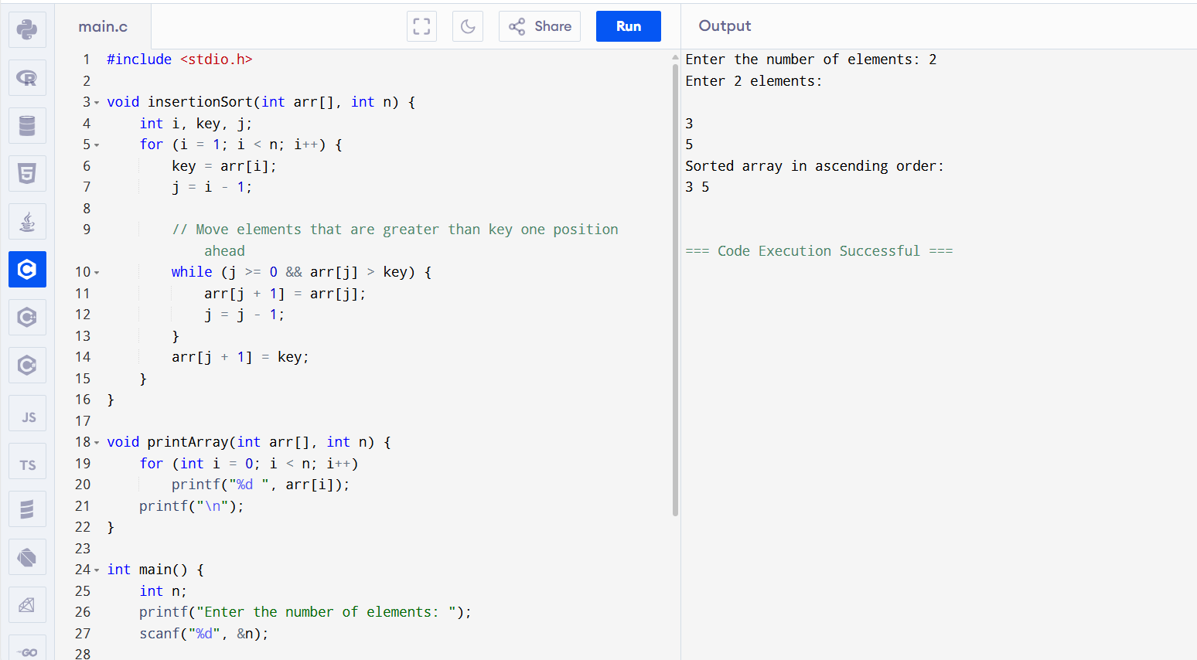

17) Write a C program to arrange a series of numbers using Merge Sort

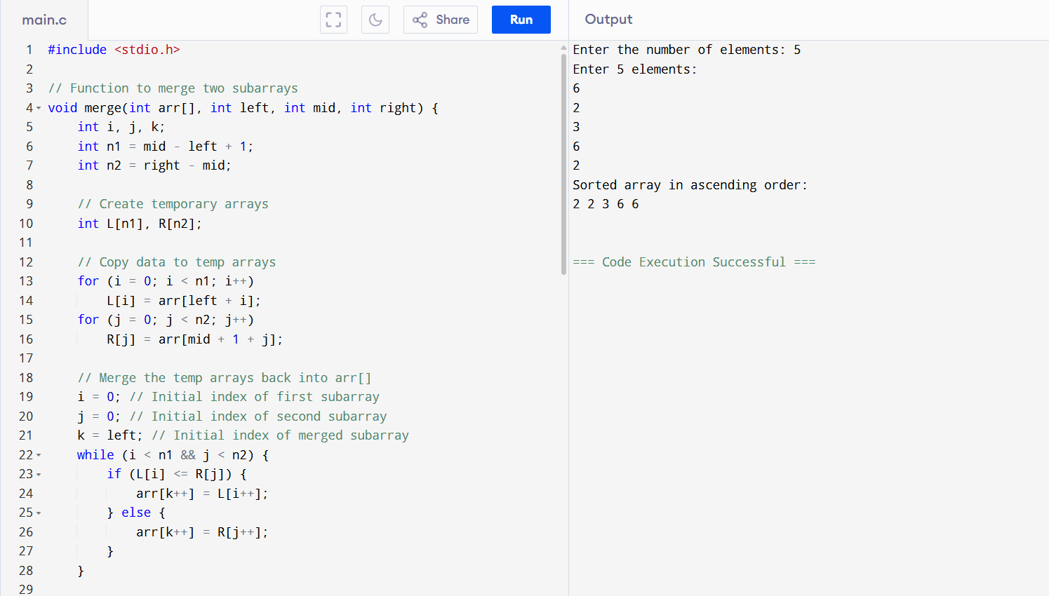

18)Write a C program to arrange a series of numbers using Quick Sort.

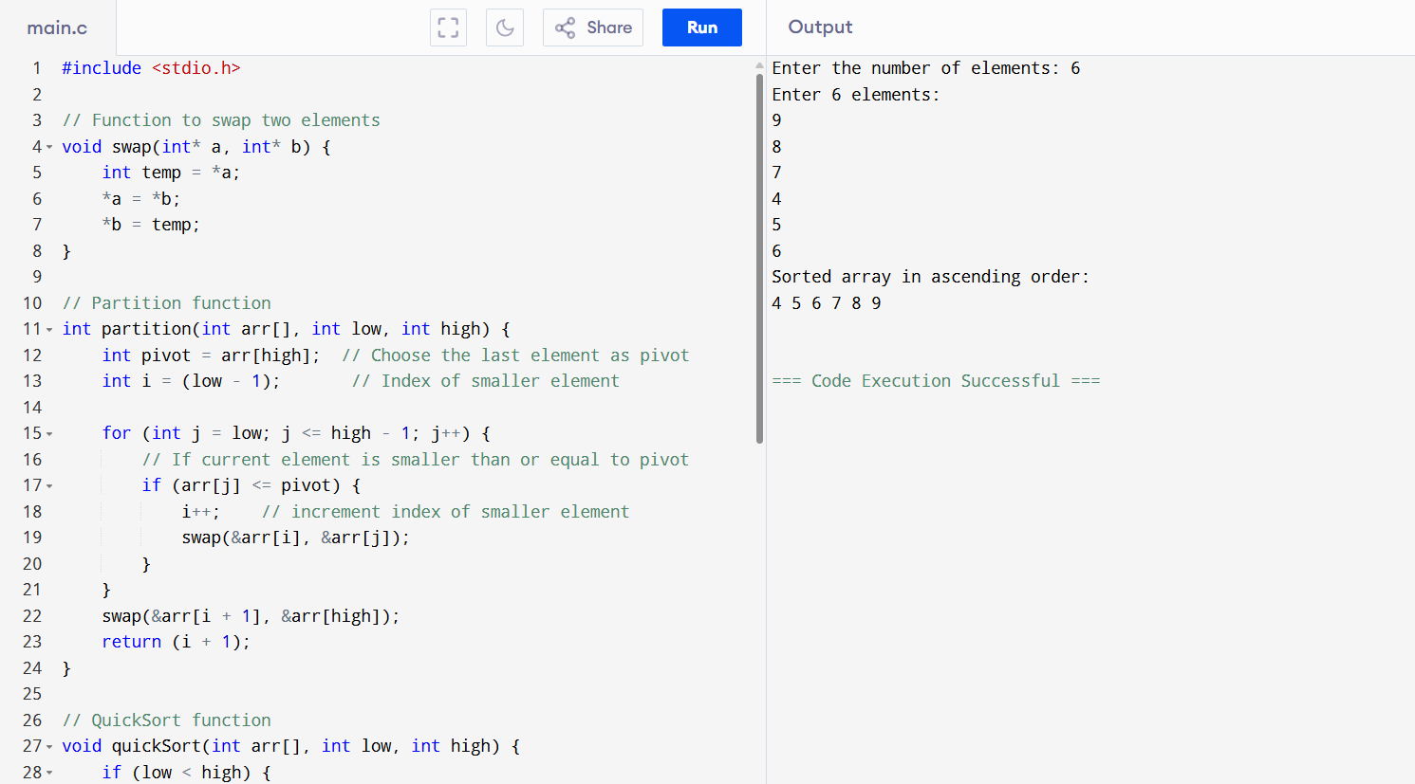

19)Write a C program to implement Heap sort

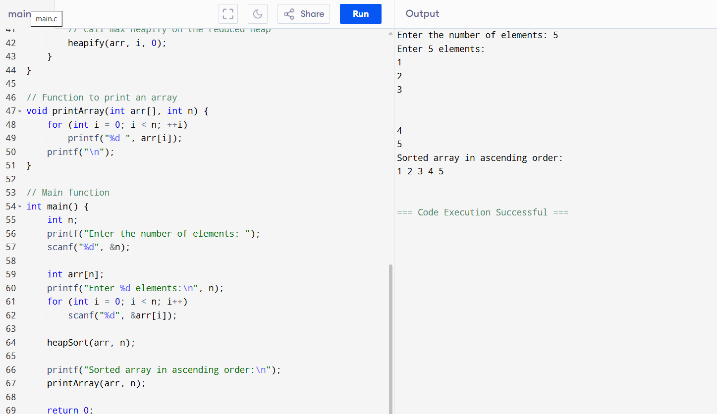

20)Write a program to perform the following operations: a) Insert anele mentinto a AVL tree b) Delete anele ment from a AVL tree c) Search for a key elementin a AVL tree

